**Tailing Mixing of filtered cake with coarse rejects for Co-disposal**

(Mineral Processing and Extractive Metallurgy)

**Jason Palmer1, Hilario Gorvenia2 and Einari Ojala3**

1Jason Palmer: Metso, Eagle Farm QLD 4009, Brisbane, Australia (jason.palmer@metso.com and 408941139)

2 Hilario Gorvenia: Metso, Av Derby 055 Surco, Lima, Peru (hilario.gorvenia@metso.com and 999437055)

3 Einari Ojala: Metso, Cerro El Plomo 5680 Las Condes, Santiago, Chile (einari.ojala@metso.com and 973891952)

____________________________________________________________________________________

**SUMMARY**

The co-disposal of filter cake with coarse rejects represents an evolving approach in tailings storage, driven by the Global Industry Standard on Tailings Management (GISTM) to ensure safe storage in perpetuity and improve water efficiency. Despite hesitance to shift to filtered dry stack methods, co-disposal has garnered significant interest due to successful plant trials. The dewatering operations and geotechnical properties of the materials involved are well understood. However, successful co-disposal requires efficient blending and transportation systems.

Mixing liquids and dry solids is relatively straightforward and backfill operations have been mixing wet cake with slurry on a small scale. For large-scale operations, where dry cake from pressure filters must be homogeneously blended with coarse rejects, the properties of the cake can represent a greater challenge need to be well defined.

During filtration within a filter the slurry moisture transitions from a dense paste through a plastic phase to a dry and friable consistency as water is removed. The more water that is removed the more complex the separation and generally this equates to higher pressures, large equipment and higher costs. Many backfill operation use vacuum filters where the cake is wet at a point where it is conveyable but still with a liquid consistency that is easily re-pulpable, well above an acceptable stacking moisture. Filtered cake for dry stacking must be dryer close to the optimum stacking moisture with solid characteristics beyond the plastic phase toward a dry and friable consistency to form a stable structure and to enable homogeneous mixing. This mixing is important as

Waste rock has superior strength than tailings, filling the void between coarse waste is the target and layers of unmixed tailings may create weak points in the tailings storage deposit.

Two geotechnical industry measurements are the soil classification of Atterberg which can describe the liquid limit and plastic limit and the Transportable moisture limit which describes a point where the cake will not liquify under vibration, similar to flow table. The moisture required for stacking lies somewhere between these areas of definition. Geotechnical design sets the target for placement however the cake solid characteristics for transportation and mixing are somewhat subjective without a systematic means of description.

This paper presents a series of lab trials aimed at characterizing the relationship between cake moisture and blendability. While free-flowing materials can be readily blended, filter cake is not free-flowing and often requires shear to reduce the cake lumps to a size suitable for disposal. The tests aim to establish a repeatable and simple method to characterize the amount of energy and time required to blend filtered cake with dry waste material.

The lab-scale test procedure involves several key steps. First, the range of testing should be linked to the geotechnical properties without necessarily having the site specific design criteria, it should be broad enough to cover a credible design range. For this reason the testing has been linked to a Proctor measurement. While co-disposal involves a mixture with waste the waste to cake ratio is not necessarily known and the waste may not be available. The testing should utilise a standard construction material to represent waste at a range of ratio’s broad enough to cover mix designs.

Next, the production of cake and simulation of the discharge prior to transportation is conducted. The way that the material behaves under a standardised drop is evaluated by the size reduction.

Then the behaviour of material under blending conditions with waste is evaluated.

Achieving a uniform mixture is essential for the successful co-disposal of filter cake with coarse rejects. The trials measure the homogeneity of the blend by analysing samples taken from different points within the mixture. This helps to identify any inconsistencies and areas where further mixing may be required.

Overall, these lab trials provide valuable insights into the blendability of filter cake and the factors that influence its successful co-disposal with coarse rejects. The findings will help to optimize the mixing process, ensuring safe and efficient disposal of tailings while improving water efficiency and meeting the requirements of the Global Industry Standard on Tailings Management (GISTM).

**1. Introduction**

“The Global Industry Standard on Tailings Management strives to achieve the ultimate goal of zero harm to people and the environment with zero tolerance for human fatality.”

Tailings dams should be of a robust design taking consideration of the risks and consequences of their construction with well proven construction methods.

One generally accepted construction material is the sand extracted from the tailings, to be an acceptable building material the sand must be compactable to a minimum density that will achieve the necessary structural strength and to have good drainage properties.

Due to the nature of generating and transporting the sand its initial saturation will be high and this needs to be reduced and controlled as saturation of the sand is as one of the greatest dangers for stability. While the sand itself must have an acceptable drainage property, a base drainage is required to remove excess water, and the structure needs to be controlled and measured to ensure the piezometric levels in the dam are at a safe level.

Governance of tailings dam management is increasing and while it is the operators of TMFs that have the primary responsibility for ensuring the safety of TMFs and for formulating and applying safety management procedures, as well as for utilizing technology and management systems to improve safety and reduce risks. The methodology of producing a construction material has inherent risks and quality is measured post deposition.

**2. Goals**

* A series of lab trials aimed at characterizing the relationship between cake moisture and blendability.
* The tests aim to establish a repeatable and simple method to characterize the amount of energy and time required to blend filtered cake relative to the cake moisture.

**3. Soil Classification**

Atterberg limits tests are not required for this test program, but they help contextualize the range of testing. The guide for Atterberg testing of the liquid and plastic limits of soils sets the upper range of interest in filter cake behaviour.

In Atterberg testing, the moisture content at the transition from a semi-solid to a plastic state is the plastic limit (PL), the transition from a plastic to a liquid state is the liquid limit (LL) and less often reported is the shrinkage limit (SL) form the basis for soil classification.

For this test program, the target for cake properties will be on the dry side of the shrinkage limit, partially desaturated within the solid range (see figure 1). The percentage of moisture content at which the transition from a solid to a semi-solid state occurs is defined as the shrinkage limit (SL) in Atterberg tests. However, for this program, it will be defined as the "cake shrinkage limit" (CSL). This is the moisture content at the end of cake pressing, evaluated from cake analysis, where moisture is removed from the cake by displacement with air rather than compression. The area of interest is the solid desaturation zone, where the filtered cake contains three phases.

Figura 1 Qualitative positions of Atterberg limits on a moisture content scale

**5. Specific Goals Filtration**

With the filtration moisture targets set against the proctor results for this study, one representative type of tailing generated at the mining operation was selected. This differentiation will allow for the analysis of the effect of initial particle size distribution on filtering capacity, cohesiveness, fragmentation, and compaction response, key aspects in the design of co-disposal mixtures.

The samples selected for the study was fine tailing with p80 32 um

* Evaluate the effect of different operating conditions (pressure, pressing, and drying times) on the final moisture content of the filter cake.
* Determine optimal cycle times to achieve moisture levels close to the optimal geotechnical range of the soil.
* Establish filtration capacity in terms of productivity and air consumption.

**Data Collection and Work Development**

The biggest drivers of the project are operating cost are the capacity vs moisture performance.

Capacity moisture trade-off can be well simulated at pilot scale and the results would be accurately representing full scale operation. For the purposes of testing where most process variables are held constant with the exception of filter changes.

For the current scenario testing the number of variables should be reduced to enable a high-level decision on the best scenario. Process variables have a constant value for each day trial.

Tabla 1 Process variables

|  |  |  |
| --- | --- | --- |
| Variable |  | Value |
| Slurry pH | Constant value | 10.5 |
| Slurry temperature | Constant value | 25°C |
| Slurry D.S. content | Constant value | 60% w/w |
| Slurry P80 | Constant value | 32um |
| Pumping pressure | Constant value | 6 bar |
| Pressing pressure | Constant value | 12 bar |
| Drying air pressure | Constant value | 6 bar |

The test equipment for filtration test is shown below

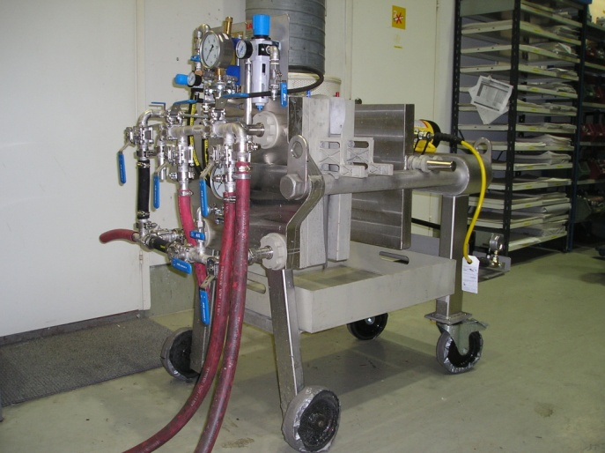

Figura 2 MFP 0.3 test filter

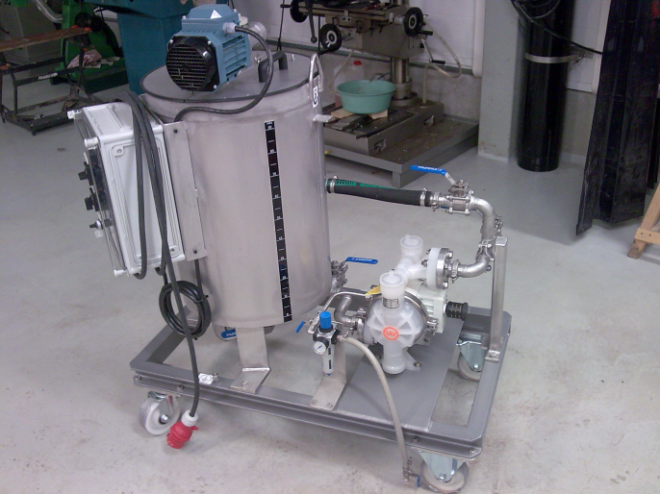

Figura 3 Feed tank and pump - MFP 0.3 test filter

The MFP 0.3 test filter membrane pressure main dimensions are 1500 x 870 x 1300 mm (L x W x H). Weight of the laboratory filter is 520 kg.

* Filter area 0.27 m²
* Two-way filtration (1 chamber)
* Maximum operating pressure for the unit 16 bar
* The filter body is made of AISI316, AISI316L and AISI304
* Pressing plates are made of AISI316L
* Piping and valves are made of AISI316
* Filter plate pack and filter cake box are made of polypropylene
* Pressing diaphragm and sealing made of rubber
* Manually operated hydraulic unit does the closing of the filter. The operating pressure max. 700 bar
* Chamber height options: 25, 40,45, and 60 mm

**Tests on the Metso FP 0.3 laboratory membrane filter press will result following data:**

* Total length of cycle time including individual phases [min]
* Filter capacity [l/m²h or kg/m²h d.s.]
* residual moisture in the cake [%]
* solids in the filtrate [mg/l]
* air consumption [m/m²min]

Prepare a series of filter cakes of a minimum of 5 kg on a Metso FP0.3 or similar test filter. The cakes should have a moisture close to the optimum geotechnical soil moisture, at 85%, 90% and 95% of optimum soil moisture, one at optimum soil moisture.

Typical filtration tests are required to establish the cycles for the target moisture

Tabla 2 Filtration cycle time

|  |  |  |  |  |
| --- | --- | --- | --- | --- |
| Description | Moisture | | | |
| Cycle time | 85% | 90% | 95% | opp |
| Pumping time | X1 | X1 | X1 | X1 |
| Pressing time | X3 | X3 | X3 | X3 |
| Drying time | X5 | X5 | X5 | X5 |

After filtration take the cake with minimum disturbance from the filter in preparation for the cake properties tests.

1. **Flow diagram**

The following diagram describes the proposed experimental flow to evaluate the technical feasibility of co-disposing filtered tailings with coarse aggregate (crushed rock) as a sustainable tailings management alternative.



Figura 4 Flowsheet

1. **Test results**

**7.1 Sample preparation**

This preparation was carried out under controlled laboratory conditions, replicating typical plant operating parameters to ensure representative results.

A target solids concentration of 60% by weight was used, a value characteristic of operations that feed high-efficiency filtration systems.

This concentration allows for a realistic evaluation of material performance in subsequent stages such as filtration, tumbling, mixing, and compaction.

Tabla 3 Physical characterization

|  |  |
| --- | --- |
| Variable | Value |
| Slurry pH | 10.5 |
| Slurry temperature | 25°C |
| Solid Content (D.S.) | 60% w/w |
| Slurry P80 | 32 um |
| Solid SG | 2.77 |

Tabla 4 Chemical analyzes

|  |  |  |  |
| --- | --- | --- | --- |
| Methods tested | Element | Unit | Value |
| 2136 | Fe | % | 8.5 |
| 598 | Ag | ppm | 1.063 |
| 598 | Al | ppm | >10000 |
| 598 | B | ppm | 89.49 |
| 598 | Ba | ppm | 62.72 |
| 598 | Be | ppm | ᵇ<0.40 |
| 598 | Bi | ppm | 47.95 |
| 598 | Ca | ppm | 4191 |
| 598 | Cd | ppm | ᵇ<0.080 |
| 598 | Co | ppm | ᵇ<0.40 |
| 598 | Cr | ppm | 143.8 |
| 598 | Cu | ppm | 797.0 |
| 598 | Fe | ppm | >10000 |
| 598 | Ga | ppm | 64.14 |
| 598 | In | ppm | ᵇ<1.6 |
| 598 | K | ppm | 3671 |
| 598 | Li | ppm | 132.9 |
| 598 | Mg | ppm | 6604 |
| 598 | Mn | ppm | 764.5 |
| 598 | Mo | ppm | ᵇ<0.40 |
| 598 | Na | ppm | 447.9 |
| 598 | Ni | ppm | ᵇ<0.40 |
| 598 | P | ppm | 554.8 |
| 598 | Pb | ppm | 116 |
| 598 | Sb | ppm | ᵇ<0.80 |
| 598 | Se | ppm | ᵇ<1.2 |
| 598 | Sn | ppm | 60.33 |
| 598 | Sr | ppm | 9.5545 |
| 598 | Te | ppm | ᵇ<2.4 |
| 598 | Ti | ppm | 316.16 |
| 598 | Tl | ppm | ᵇ<0.80 |
| 598 | V | ppm | 27.77 |
| 598 | Zn | ppm | 544.5 |

Tested Methods

*2136 Test method for Iron by specific digestion – volumetric analysis

*598 Multi-element test method by ICP-OES with multi-acid digestion

Tabla 5 Mineralogical characterization

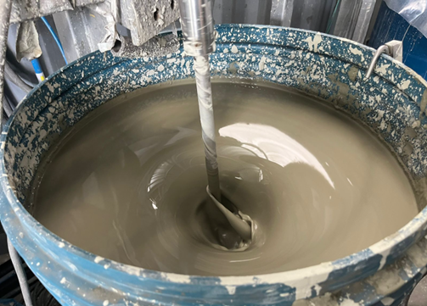

Figura 5 Sample preparation

* 1. **Filtration test**

Filtration tests were conducted using Metso's MFP 0.3 pressure filtration system, which simulates plant operating conditions in a controlled laboratory environment. This equipment is designed to evaluate cake performance under constant pressure, recording key parameters such as cycle time, filtration rate, and final cake moisture. The MFP 0.3 filter is shown below.

1. **Equipment**

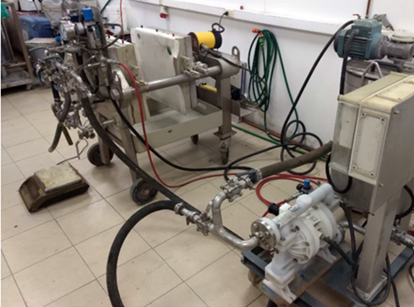

Figura 6 MFP 0.3 test filter

1. **Experimental Procedure**

Filtration tests will be performed using the Labox MFP 0.3 laboratory filter press, under constant operating conditions and varying the cake moisture content to achieve different levels of relative compaction relative to the maximum dry density determined by the Proctor test.

Key filtration cycle variables:

• X1: Pumping time

• X2: Pressing time

• X3: Drying time

The following conditions are considered constant for each test, ensuring uniformity in the tests.

Tabla 6 Filtration variables

|  |  |  |
| --- | --- | --- |
| Variable |  | Value |
| Slurry pH | Constant value | 10.5 |
| Slurry temperature | Constant value | 25°C |
| Slurry D.S. content | Constant value | 60% w/w |
| Pumping pressure | Constant value | 6 bar |
| Pressing pressure | Constant value | 12 bar |
| Drying air pressure | Constant value | 6 bar |

1. **Results**

These results allow us to establish a target reference moisture 16.2%, which will be used as a baseline parameter for the design of drop tests, and bendability studies.

Furthermore, the data obtained are essential for projecting the performance of pilot- or industrial-scale filtration systems.

Tabla 7 Filtration test results





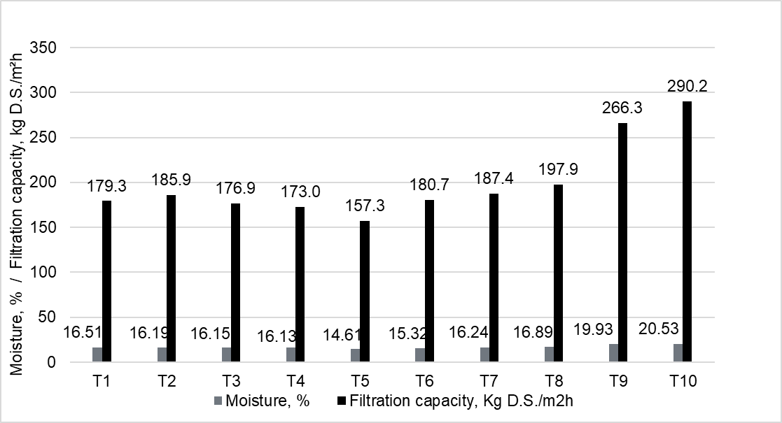

Figura 7 Comparison Filtration test results

Additional tests were conducted to determine the target moisture contents required for the filtration stage prior to performing the drop tests. These target values are based on an assumed optimal soil moisture of 17% and include the following conditions:

* 85% of the optimal moisture (14.5%)
* 90% of the optimal moisture (15.3%)
* 95% of the optimal moisture (16.2%)
* 100% of the optimal moisture (17.0%)

The moisture levels selection will serve as reference points for the subsequent drop test evaluations.

Tabla 8 Filtration test selected for cake dropping test



* 1. **Cake dropping test**

The samples produced in filtration were the source material for dropping tests. The purpose of this test is to simulate the natural discharge of filter cake from the filter press, from a height of approximately 3 meters. The objective is to evaluate the mechanical behaviour and natural fragmentation of the cake before it undergoes the mixing stage with coarse aggregate.

1. **Experimental Procedure**

Test plan/procedure Cake behavior during discharge.

During normal filter operation the cakes are dropped by at least 3 m from the chamber to the cake conveyor under the filter, this results in the chamber sized cake breaking into smaller pieces. To simulate the drop and to prepare the cake for repulping the filtered cake should be exposed to a drop of 3m, in practice a 3m drop is impractical and 3 x 1m drops are performed. The size reduction achieve during dropping is an important parameter in defining the cake properties

1. Place the cake on a 450 x 450mm board, hold 1 m above the floor and rotate the board 90 deg to drop onto a hard floor covered with plastic sheet. Photograph the cake pieces including a reference size
2. recover the cake pieces, re load the board and repeat the drop. Photograph the cake pieces including a reference size
3. Repeat the test a third time recovering the cake pieces, re load the board and repeat the drop. Photograph the cake pieces including a reference size. Recover the pieces and screen through 53mm, 26.4mm ,19mm and 12.5mm mesh wire screens to measure the size retained on each screen, The screening should be manual and gentle so as to not break the cake pieces further
4. After finish calculate the following

- Size distribution by sieve:

- Fragmentation Index (FI): FI is an indicator of the cake's mechanical fragility and can be correlated with moisture to understand its structural strength under real-life discharge conditions.

$$FI=\left(\frac{Masa pasante<12.5mm}{Masa total}\right)x100$$

1. Interpretation ranges

Since there is no universal standard for this index in filter cakes (unlike soils or rocks), we propose the following relative brittleness ranges:

Tabla 9 Relative fragility ranges



1. **Results**

The results of the cake dropping tests are summarised in the table below, the cake moistures are measured as metallurgical moisture

Tabla 10 Fragmentation analyses



The selected moisture levels correspond to different fractions of the optimal compaction value (17%), with the goal of establishing the relationship between moisture content and the Fragmentation Index (FI).

This experimental design will allow us to analyze the effect of moisture on the physical integrity of the cake upon discharge and to establish the optimal filtration range from the perspective of manageability and resistance to fragmentation.

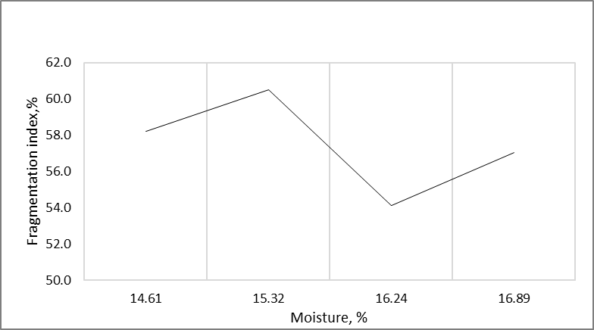

Figura 8 Fragmentation Index vs Moisture

The following figure shows the fragmentation after the first drop, second drop and third drop:

Figura 9 First drop test

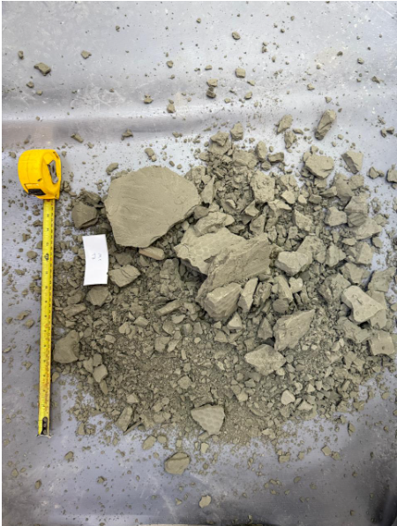

Figura 10 Second drop test

Figura 11 Third drop test

* 1. **Cake plasticity test**

The Plastic Limit (PL) is one of the Atterberg limits used to characterize the consistency and plasticity . It is defined as the lowest moisture content at which soil remains plastic and can be rolled into threads without crumbling.

The percentage of moisture content at which the transition from solid to semi-solid state takes place is defined as the shrinkage limit (SL) to be defined as the moisture at the end of cake pressing for cake analysis.

The moisture content at the point of transition from semi-solid to plastic state is the plastic limit (PL) as determined from the plastic limit test, and from plastic to liquid state is the liquid limit (LL) Not to be measured for cake properties.

1. **Experimental Procedure**

* Take approximately 20 g of filter cake.
* Record the cake moisture.
* Test if the material can be formed to a cohesive ball
* Prepare several small, ellipsoidal-shaped masses of cake on a flat surface and attempt to roll into a cylinder. Reducing diameter to 3.5mm by rolling
* If the cake crumbles forming a thread approximately record the diameter at failure.
* Collect the crumbled sample, add a small amount of water, and weigh it to determine the water content. Otherwise, repeat the test with the same cake sample until a thread can be rolled

1. **Results**

The plotted curve of Volume vs. Moisture trend , confirms the expected trend: volume increases progressively as water content rises. Each consistency state (solid, semisolid, plastic, liquid) is clearly delineated by the critical limits measured.

Tabla 11 Attergerg limits



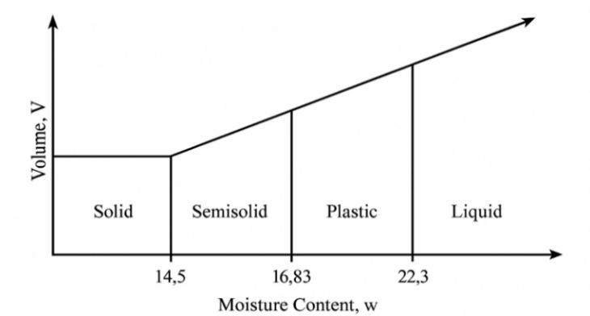

Figura 12 Volume vs. Moisture Content

The following figure shows the formation of cylindrical ellipsoidal masses.

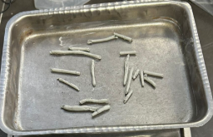

Figura 13 formation of cylindrical ellipsoidal masses.

* 1. **Bendability test**

The tests aim to establish a repeatable and simple method to characterize the amount of energy and time required to blend filtered cake with waste rock.

1. **Equipment**

Mixing simulation equipment 70l to 100l concrete mixer

Figura 14 Concrete mixer

1. **Experimental Procedure**

Using the samples prepared from the filter cake properties tests add the material to a standard 70l to 100l concrete mixer with 5-10 mm crushed rock or similar. The simulation should be conducted with a ratio of 1:0, 1:1, and 1:2 tailings to waste rock substitute.

The mixer should be set at an angle of 45 deg to simulate mixing and blending

The time required to achieve a homogenous mixture should be recorded and the end mixture should be photographed

At the completion of the mixing trial the mixer contents should be discharge and the repose of the waste/tailings pile measured

Each test will use a consistent solids load weighing approximately 8 kg of total sample.

Tabla 12 Sample preparation



1. **Sample selection**

Different mixing ratios of tailings cake to coarse aggregate will be evaluated. The aggregate used will be 4–6.3 mm crushed rock, as a representative substitute for waste rock under real-world mining conditions. As part of this study, a target moisture content equivalent to 95% of the optimum soil moisture content has been defined to maximize compaction efficiency without compromising the physical integrity of the filter cake.

The filtrate tailings sample moisture used has a moisture of 16.2% (equivalent 95% of 17% target moisture)

For each mixing level, a mixture of approximately 8 kg will be prepared per test, sufficient to complete a compaction curve with three layers.

Tabla 13 Ratio Filtrate tails: Rock



1. **Results**

The angle of repose was determined for mixtures of filtered tailings and crusher rock in different mass ratios (1:0, 1:1, 1:2). After homogenization in a rotating drum (trommel), each 8 kg mixture was discharged onto a flat surface to form a free-standing conical pile. The height and base diameter of the resulting piles were measured to estimate the repose angle.

Tabla 14 Characteristics of cone formed



The following figure shows the shape of the formed cone for final mixture:

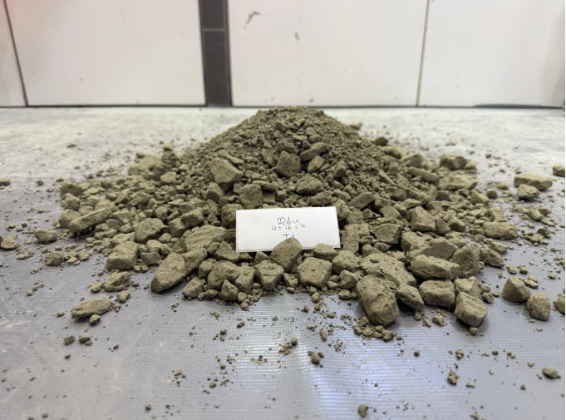

Figura 15 Shape of the formed cone ratio 1:0

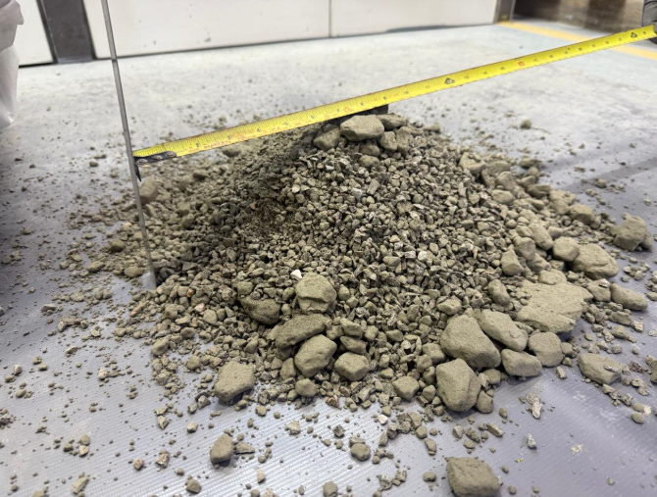

Figura 16 Shape of the formed cone ratio 1:1

Figura 17 Shape of the formed cone ratio 1:2

* 1. **Proctor Test - Compaction for Mixture (Filtered Tailings with Crushed Rock)**

To determine the compaction parameters of the filtered tailings mixture with crushed rock (maximum dry density and optimum moisture content), a Proctor-type test will be performed on the cake mixture obtained in the Metso laboratory filter. Work will be carried out at an optimum relative humidity level (95%), using a reference moisture content of 17% based on previous tests and three mixing levels.

1. **Samples**

For each mixing level, a mixture of approximately 8 kg will be prepared per test, sufficient to complete the full compaction curve with three layers. The total required is 24 kg.

Tabla 15 Sample requirements



**8. Conclusions**

**Determination of the optimal moisture range for co-disposal**

Filtration and compaction tests identified that a filter cake moisture content close to 95% of the soil’s optimum moisture (approximately 16.2%) represents an appropriate operational range. This condition favors transport, discharge, and mixing with coarse aggregate without compromising the material’s physical integrity or operational manageability.

**Relationship between moisture content and mechanical behavior of filter cake**

Drop tests from a height of 3 meters revealed a direct correlation between residual moisture and the fragmentation index (FI) of the filtered tailings. Higher moisture levels (≥ 17%) increase plasticity and reduce friability, hindering effective mixing. Conversely, very low moisture levels (< 14.5%) result in excessive fragmentation and loss of cohesion, negatively affecting process efficiency and blend quality.

**Blend homogeneity and deposit stability**

Rotary drum mixing simulations with ratios of 1:0, 1:1, and 1:2 (Tailings: aggregate) demonstrated that blend homogeneity improves significantly with controlled moisture and appropriate aggregate proportions. The 1:2 mixture achieved a lower angle of repose and more favorable particle size distribution, contributing to greater structural stability for co-disposal applications.

**Methodological approach for blendability characterization**

The study validated a reproducible laboratory-scale methodology to quantify the energy and time required to mix filtered tailings with coarse aggregate. This approach enables the definition of optimized filtration and mixing conditions that enhance process efficiency while meeting geotechnical criteria set by international standards such as the Global Industry Standard on Tailings Management (GISTM).

**Considerations for scaling and industrial implementation**

While laboratory results are promising, pilot or full-scale validation is required. Implementing co-disposal systems demands investment in filtration, mixing, and geotechnical monitoring equipment. However, these initial costs are offset by improvements in operational safety, environmental sustainability, water efficiency, and the reduction of liabilities during mine closure.

**9. References**

Sergio Barrera. (2015) ‘*Reassessment of best available tailings management practices’*, Proceedings Tailings and Mine Waste.

Global tailings review org. (2020)’ Global Industry standard on tailings management ‘.

Jason Palmer

Breve reseña profesional

Chemical Engineer with over 40 years’ experience in the mining and metallurgical industries. Working in a wide range of roles from Research, Equipment and plant design through project management, commissioning, and site service.

Specializing for many years in dewatering with a particular emphasis on tailings applications from pumping of slurries, through thickening to dewatering in filters and interfacing with waste storage facilities.

Hilario Gorvenia

Breve reseña profesional

MBA en Gestión Minera e Ingeniero Metalurgista Colegiado y Habilitado. Con más de 23 años de experiencia en la industria de minería, en gestión de plantas, comisionamiento, arranque y ramp-up de Plantas, liderazgo transformacional, cultura de seguridad sostenible y logro de objetivos estratégicos en diversas compañías mineras, como Glencore, Antamina, Grupo Hochschild, Compañía Minera Ares, Minera Santa Cruz, Gold Fields, Chinalco, Antapaccay y Nexa Resources, Actualmente, Gerente de Procesos en Metso.

Einari Ojala

Breve reseña profesional

Mining and Minerals Processing Engineer

from Helsinki University of Technology, Finland,

with 29 years’ experience in Outokumpu

Technology (Outotec) and Metso group companies,

based more than 20 years in Chile and Peru.

Different roles with plant operation and start-up,

process equipment delivery and EPC projects,

crushing and concentrator plant project

implementation and technology sales.